Question 1: SJF Non-Preemptive Scheduling Calculation.

Process | AT | BT
P1 | 0 | 6
P2 | 1 | 8
P3 | 2 | 7
P4 | 3 | 3

1.Draw the Gantt chart for Shortest Job First (Non-Preemptive) scheduling.
Process | P1 | P4 | P3 | P2
Time | 0 – 6 | 6 - 9 | 9 - 16 | 16 - 24

2.Calculate Completion Time (CT), Turnaround Time (TAT), and Waiting Time (WT) for each process.
Process | AT | BT | CT | TAT(CT-AT) | WT(TAT-BT)
P1 | 0 | 6 | 6 | 6 | 0
P2 | 1 | 8 | 24 | 23 | 15
P3 | 2 | 7 | 16 | 14 | 7
P4 | 3 | 3 | 9 | 6 | 3

3.Compute the Average Waiting Time (AWT) and Average Turnaround Time (ATAT).
Here,
$Average Waiting Time \left(AvgWT\right)=\frac{6+23+14+16}{4}=12.25$

Question 2: SJF Non-Preemptive C Program Implementation.
Write a C program to implement Shortest Job First (SJF) Non-Preemptive CPU Scheduling.
The program should:
1. Take number of processes, arrival times, and burst times as input.
2. Calculate WT, TAT, CT for each process.
3. Print Average WT and Average TAT.
4. Show a simple textual Gantt chart.

Code:
#include <bits/stdc++.h>
#include <iomanip>
using namespace std;

int main()
{
int n;
cout << "Enter number of processes: ";
cin >> n;

int at[100], bt[100], tat[100], wt[100];
int completed[100];
int gantt[100];
int time_mark[101];

for(int i=0;i<n;i++)
completed[i] = 0;

cout << "Enter Arrival Time and Burst Time\n";

for(int i=0;i<n;i++)
{
cout << "P" << i+1 << ": ";
cin >> at[i] >> bt[i];
}

int current_time = 0;
int completed_count = 0;
int k = 0;

time_mark[0] = 0;

while(completed_count < n)
{
int idx = -1;
int min_bt = 9999;

for(int i=0;i<n;i++)
{
if(at[i] <= current_time && completed[i] == 0)
{
if(bt[i] < min_bt)
{
min_bt = bt[i];
idx = i;
}
}
}

if(idx != -1)
{
current_time += bt[idx];

tat[idx] = current_time - at[idx];
wt[idx] = tat[idx] - bt[idx];

completed[idx] = 1;

gantt[k] = idx;
time_mark[k+1] = current_time;

k++;
completed_count++;
}
else
{
current_time++;
}
}

float avgWT = 0, avgTAT = 0;

cout << "\n";
cout << left << setw(10) << "Process"
<< setw(10) << "AT"
<< setw(10) << "BT"
<< setw(10) << "WT"
<< setw(10) << "TAT" << endl;

for(int i=0;i<n;i++)
{
cout << left << setw(10) << ("P"+to_string(i+1))
<< setw(10) << at[i]
<< setw(10) << bt[i]
<< setw(10) << wt[i]
<< setw(10) << tat[i] << endl;

avgWT += wt[i];
avgTAT += tat[i];
}

cout << "\nAverage WT = " << avgWT/n;
cout << "\nAverage TAT = " << avgTAT/n;

cout << "\n\nGantt Chart:\n";

for(int i=0;i<k;i++)
cout << "| P" << gantt[i]+1 << " ";

cout << "|\n";

for(int i=0;i<=k;i++)
cout << time_mark[i] << " ";

cout << endl;

return 0;
}

OUTPUT:

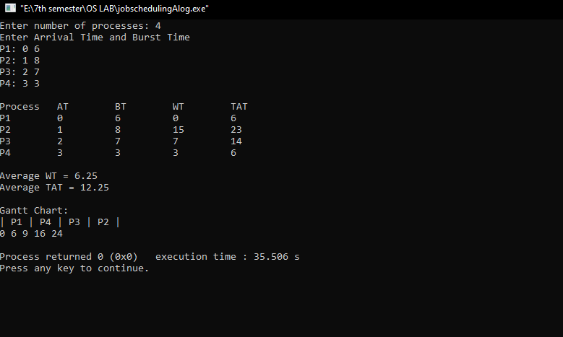

Question 3: Analytical Comparison

Compare SJF Non-Preemptive with FCFS for the following processes:
Process | AT | BT
P1 | 0 | 6
P2 | 1 | 8
P3 | 2 | 7
P4 | 3 | 3

- By using SJF:

Average Waiting Time (AvgWT)$=\frac{0 + 15 + 7 + 3}{4}= 6.25$
Average Turnaround Time (AvgTAT)$=\frac{6 + 23 + 14 + 16}{4}=$12.25

- By using FCFS:

Process | P1 | P4 | P3 | P2
Time | 0 – 6 | 6 - 14 | 14 - 21 | 21 - 24

So,
Process | AT | BT | CT | TAT(CT-AT) | WT(TAT-BT)
P1 | 0 | 6 | 6 | 6 | 0
P2 | 1 | 8 | 14 | 13 | 5
P3 | 2 | 7 | 21 | 19 | 12
P4 | 3 | 3 | 24 | 21 | 18

Average Waiting Time (AvgWT)$=\frac{0 + 5 + 12 + 18}{4}= 8.75$
Average Turnaround Time (AvgTAT)$=\frac{6 + 13 + 19 + 21}{4}=$14.75

In conclusion, Average Waiting Time and the Average Turnaround Time in SJF schedule
is less than the FCFS schedule process. Thus, the SJF schedule process is better than FCFS
schedule process for this given process.

